

DataShare

Admin User Guide

**Redbridge** a better place to live



London Borough of

**Redbridge**



v1.5

Contents

Introduction 3

Terminology 3

Conventions 3

Accessing the admin area 4

The admin menu 5

Changing your password 6

DataShare administrators 7

Creating administrators 8

Editing administrators 9

Removing administrators 10

DataShare configuration settings 11

Managing schemas 13

Creating a schema 15

Importing a schema 16

Creating a schema from scratch 17

Editing a schema 23

Editing the schema’s classification 24

Adding a Function/Service classification 24

Removing a Function/Service classification 24

Editing the schema structure 25

Adding a field 25

Editing a field 25

Deleting a field 26

Changing the order of fields 27

Changing a schema’s online status 27

Approving a schema 27

Taking a schema offline 27

Putting a disabled schema back online 27

Deleting a schema 28

Managing data 29

Uploading data 30

Supporting files 31

Auto-upload 31

Deleting data 32

Managing categories 33

Create a category 34

Editing a category 34

Changing a category’s online status 35

Taking a category offline 35

Putting a disabled category back online 35

Feedback 36

Service history and errors 37

Service history 37

Errors 38

Appendices 39

Planning a schema 39

DataShare API 39

HTML editor 40

Inserting an image 40

Creating a hyperlink 41

# Introduction

http://data.redbridge.gov.uk/Content/images/DataSpaceLogo.pngAchieving greater transparency of public bodies is a central theme of the Government's programme. The Secretary of State for Communities and Local Government has instructed local authorities to take a proactive stance to publishing all information and in so doing making sure that it is easy to find and understand.

Government guidance states that data must be published without restriction. Public data should be released in an "open format" that is reusable, available to everyone to be exploited for social and/or commercial purposes.

DataShare was developed by the London Borough of Redbridge as a way to make accessing and inspecting this data easier for everyone; as well as more simple for developers wishing to use the data in their applications, web sites and widgets.

*“This is great stuff! Clean, clear and some cool datasets – really first rate. Something for others to aspire to…”*

Professor Nigel Shadbolt, Southampton University   
Public Sector Transparency Board, Local Public Data Panel Chair

*“DataShare is an impressive tool able to meet the open data demands of both the council and public”*

Julian Mund, Markets and Product Development Director, CIPFA

*“That’s brilliant. Really impressed by your system and I’ve been praising it to whoever I can.”*

Chris Taggart, CEO & Co-Founder OpenCorporates, Founder OpenlyLocal,   
Member of Local Public Data Panel, Member of Mayor of London’s Digital Advisor

This document is a guide to using the DataShare administration system enabling the population of your open data site.

The DataShare site and its administration area are compatible with all current desktop web browsers.

## Terminology

The following table defines the terms referred to within the DataShare admin area and this document.

|  |  |
| --- | --- |
| Category | A group of related schemas. |
| Schema | The definition of a data set including descriptive meta data, how frequently the data will be updated and the structure of the data itself. |
| Data set | An instance of data uploaded to a schema. |
| User | An administrator who uses the DataShare admin area. |
| CSV | A comma-separated values (CSV) file is a simple text format for a database table.  See <http://en.wikipedia.org/wiki/Comma-separated_values> for more details. |

## Conventions

Throughout this document the following conventions are used.

|  |  |
| --- | --- |
| ***Bold italic*** text | A clickable element on a page, e.g. a button |
| <datashareurl> | The address of the main, public DataShare site, e.g. http://data.mycouncil.gov.uk |

# Accessing the admin area

Follow the steps below to access the admin area of your DataShare site:

1. In your web browser go to: <datashareurl>/admin e.g. http://data.mycouncil.gov.uk/admin
2. 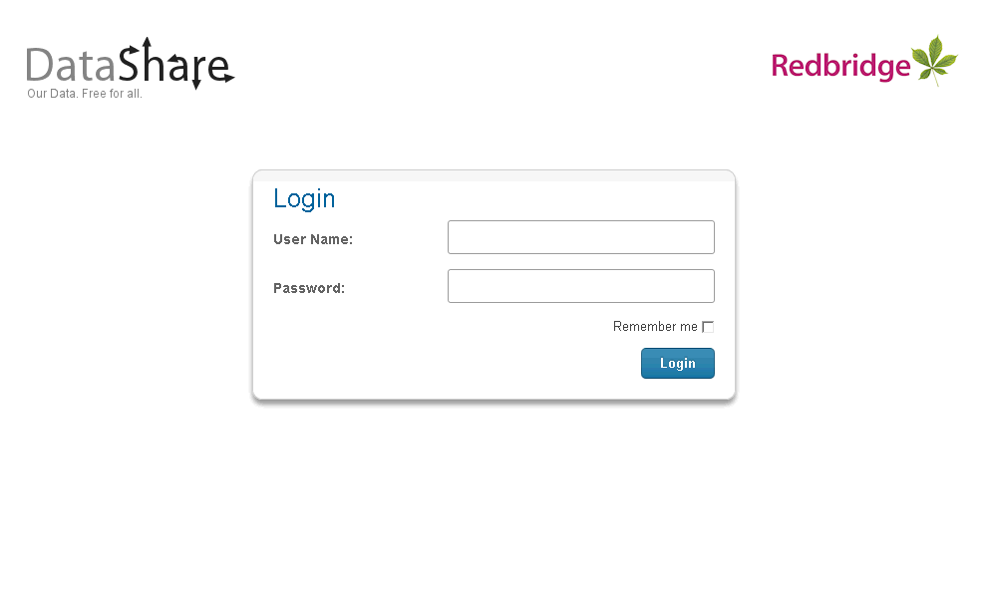You will see the following page asking for your user name and password:
3. Enter your user name and password in the relevant boxes.
4. Click the ***Login*** button.

If your login attempt was not successful you will be asked to try again.

## The admin menu

Upon successfully logging in you will see the DataShare admin menu:

Depending on the role allocated to you by the system administrator you may not see all of the options shown above. See the section about User types on page 8 for more information about the roles available.

The options on this page allow you to:

|  |  |
| --- | --- |
| ***Upload and edit data*** | Manage the data associated with a given schema. |
| ***Create and edit schemas*** | Create, edit and delete DataShare schemas. |
| ***Add and edit categories*** | Manage the categories that group DataShare schemas. |
| ***Add and edit users*** | Create and manage other DataShare administrators. |
| ***View feedback*** | View comments, suggestions and requests submitted by site visitors. |
| ***View errors*** | See a record of any errors that DataShare users may have encountered. |
| ***View service history*** | Details of events raised by DataShare’s automated service. |
| ***Edit System Configuration*** | Change system wide DataShare settings. |

In addition to these options, all pages include the following:

|  |  |
| --- | --- |
| ***Logout*** | Log out of the admin area. |
| ***Change password*** | Change your admin password. |
| ***View site*** | View the public “front end” site. |

Pages may also include the following:

|  |  |
| --- | --- |
| ***Back*** | Return to the previous page, abandoning any changes. |

Click the DataShare logo on any admin page to return to this menu.

## Changing your password

Once logged in, any user is able to change their password:

1. From any admin page click the ***Change password*** button.
2. The system displays the Change your password page: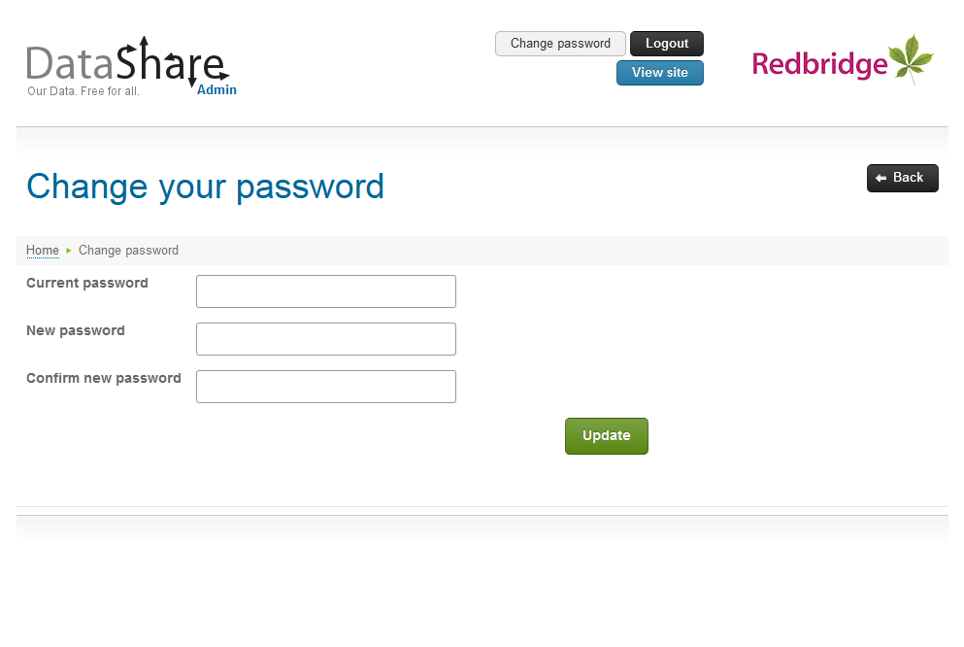
3. Enter your current password, new password and confirm the new password. Passwords must be at least seven characters long.
4. Click the ***Update*** button.
5. The system will validate the details entered; any errors will be displayed on the page and must be corrected before continuing.
6. If all details are valid the system will update your password.
7. Click ***Back*** to return to the admin menu.

Super administrators can change the password of any user, see Editing administrators on page 9.

# DataShare administrators

DataShare super administrators have the ability to create and amend other administrators. To manage DataShare administrators:

1. From the DataShare super administrator’s menu select the ***Add and edit users*** option.
2. The system displays the DataShare users page.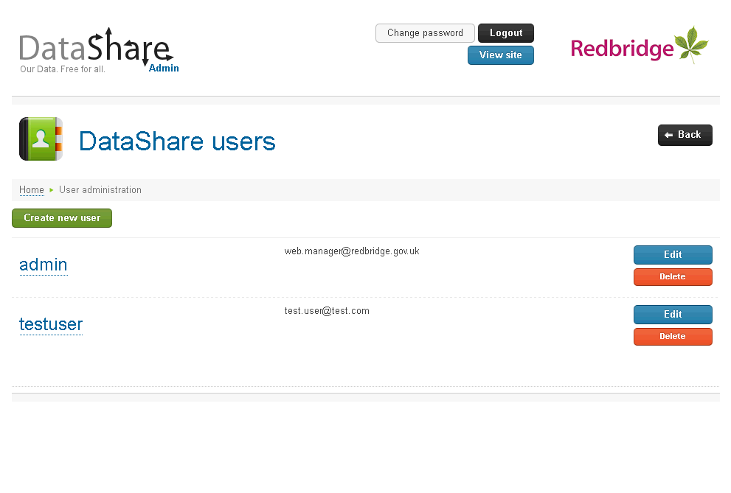

## Creating administrators

To create a new DataShare user:

1. From the DataShare users page click the ***Create new user*** button.
2. The system displays the Create DataShare user page: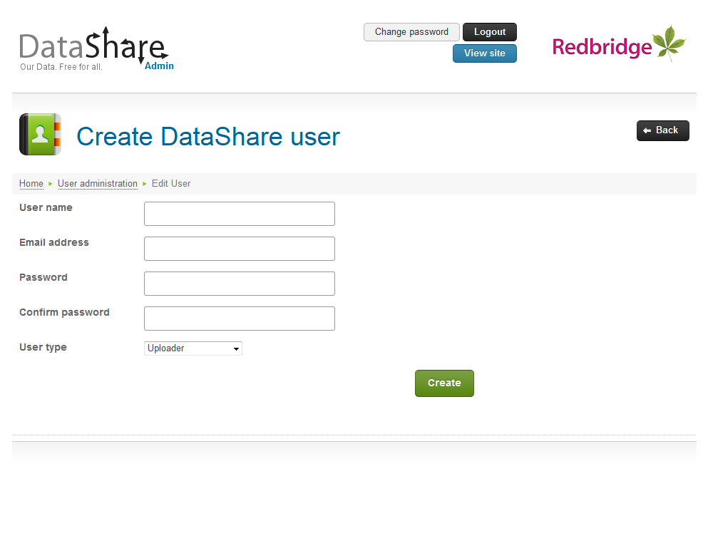
3. Complete the form as described below:

|  |  |
| --- | --- |
| User name | The name that the administrator will use to log on to the system. |
| Email address | The email address of the administrator. |
| Password | The password the administrator will use to access the admin system. Passwords must be at least seven characters long.  This can be changed by the user at any time (see page 6). |
| Confirm password | Confirm the password. This must match the password entered above. |
| User type | The role this administrator will perform in the production of data.  Uploader Can upload data against a schema only.  SchemaEditor Can amend a data set’s schema and upload data.  SchemaCreator Can create a new data set schema, amend it and upload data.  SuperAdministrator Can perform all administration tasks including the approval of new schemas. |

1. Click the ***Create*** button.
2. The system will validate the details, e.g. ensuring user names and email addresses are unique. Any problems will be displayed on the page and must be corrected before the user can be created.
3. Upon successful creation the system will return to the DataShare users page and display a confirmation message.

## Editing administrators

Editing a user allows you to reset their password and change their email address or role.

1. From the DataShare users page click the ***Edit*** button alongside the administrator you wish to amend.
2. The system displays the Edit DataShare user page: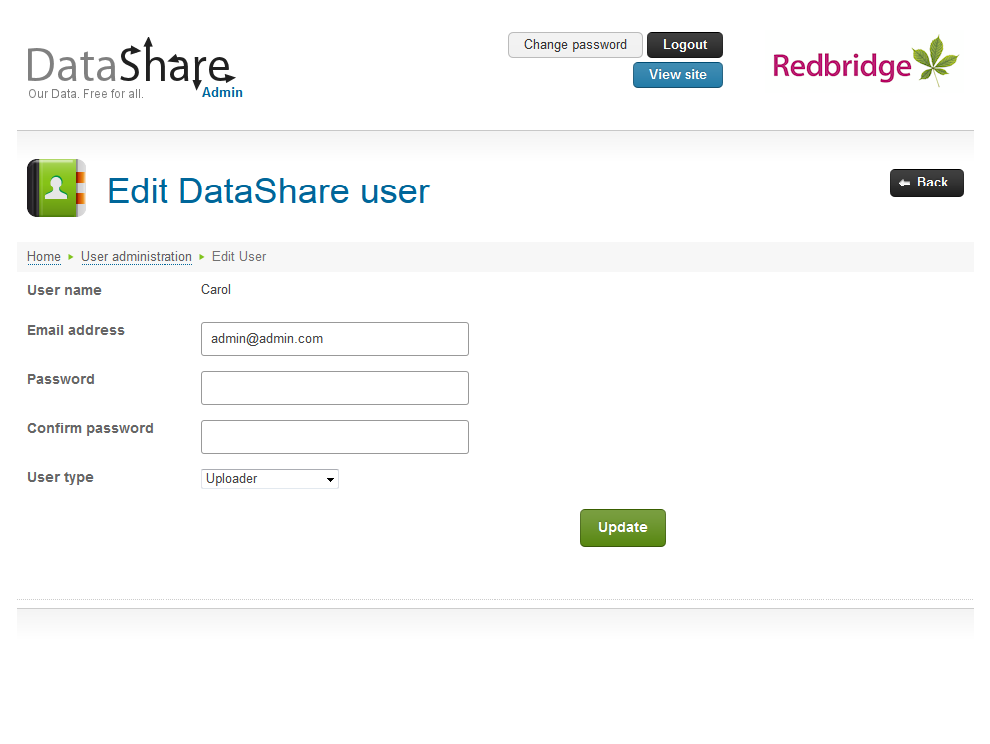
3. Amend the administrator’s details as required:

|  |  |
| --- | --- |
| Email address | The email address associated with the user. |
| Password/ Confirm password | Enter both to reset the administrator’s password. Passwords must be at least seven characters long. The password and confirm password must match.  Leave these blank if you do not wish to reset the administrator’s password. |
| User type | The role this administrator will perform in the production of data, see the section on User types on page 8. |

The user name is displayed on the Amend DataShare User page for information purposes only, it cannot be changed.

1. Click the ***Update*** button.
2. Any problems with amending the administrator’s details will be displayed on the screen and must be corrected.
3. Upon successfully amending the administrator’s details you will be returned to the DataShare users page.

## Removing administrators

To remove a user from the system:

1. From the DataShare users page click ***Delete*** alongside the user you wish to remove.
2. The system will ask you to confirm that you wish to remove the administrator.
3. Click ***Yes*** to remove the user, or ***No*** to cancel the deletion and retain the user.

# DataShare configuration settings

DataShare super administrators have the ability to make changes to DataShare’s system wide settings. To amend the system configuration:

1. From the DataShare super administrator’s menu select the ***Edit system configuration*** option.
2. 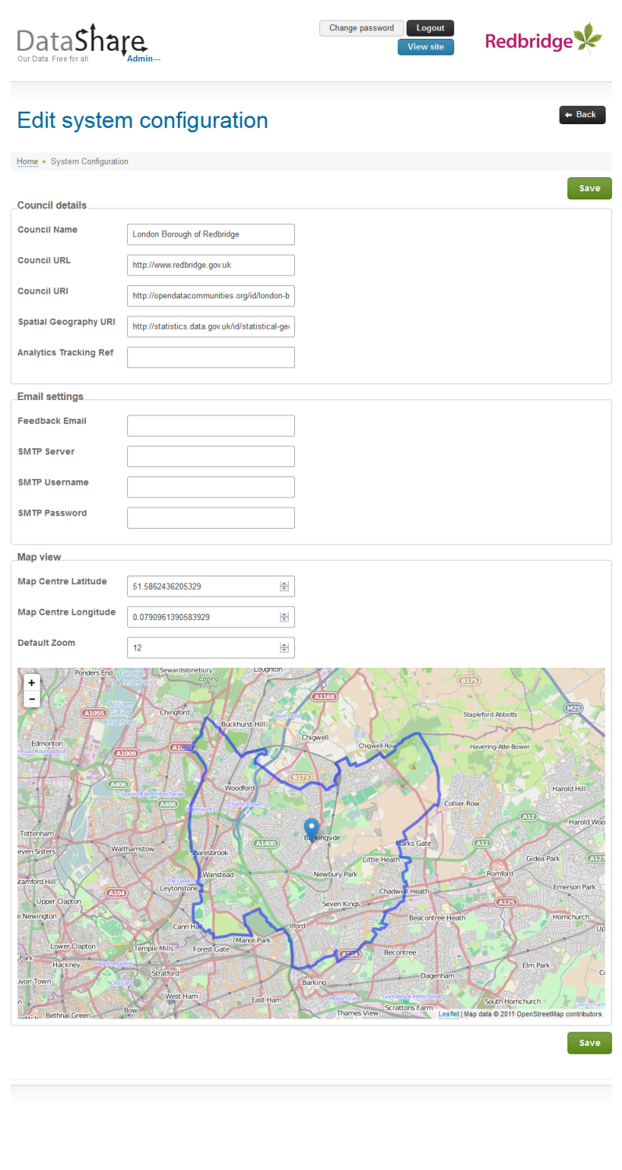The system displays the Edit system configuration page.
3. Complete the form as follows:

|  |  |
| --- | --- |
| **Council details** | |
| Council Name | The name of your Authority. |
| Council URL | The URL of the Authority’s main website. |
| Council URI | The URI of your Authority on the DCLG linked open data portal, e.g. the URI for Redbridge is <http://opendatacommunities.org/id/london-borough-council/redbridge>.  The URI that can be found at <http://opendatacommunities.org>. |
| Spatial Geography URI | The spatial geography URI of your Authority on the ONS linked data portal, e.g. the spatial URI for Redbridge is <http://statistics.data.gov.uk/id/statistical-geography/E09000026>.  The URI can be found at <http://statistics.data.gov.uk/explore>.  Supplying this will automatically complete the map view settings below. |
| Analytics Tracking Ref | If you wish to use Google Analytics to track visits to DataShare you must provide the tracking ID of the property you will be using. |
| **Email settings** | |
| Feedback email | The email address that email notifications for feedback/contact us submissions should be sent to. Leave this blank if you do not wish to receive such notifications |
| SMTP Server | The name or IP address of the SMTP server. This **must** be provided if an email address is entered above. |
| SMTP Username/Password | The credentials to use to access the SMTP server (if required). |
| **Map view** | |
| Map Centre Latitude/Longitude | The longitude and latitude of the point that you would like any map view to be centred on.  You can set these easily by dragging the marker on the map to the required location. |
| Default Zoom | The zoom level you would like any map view to start on. This should be a number between 1 (the whole world) and 18 (individual streets).  You can also set this value by adjusting the zoom control on the map displayed. |

1. Click the ***Save*** button

# Managing schemas

Only administrators in the SchemaCreator, SchemaEditor and SuperAdministrator roles can manage schemas.

Schemas define the datasets that you wish to upload to DataShare. They describe what the data set is about, how frequently the data should be updated and the structure of the data itself.

For advice about schemas and structuring data see on page 39.

To manage DataShare schemas:

1. From the DataShare menu select the ***Create and edit schemas*** option.
2. The system displays the Manage schemas page, listing all available categories: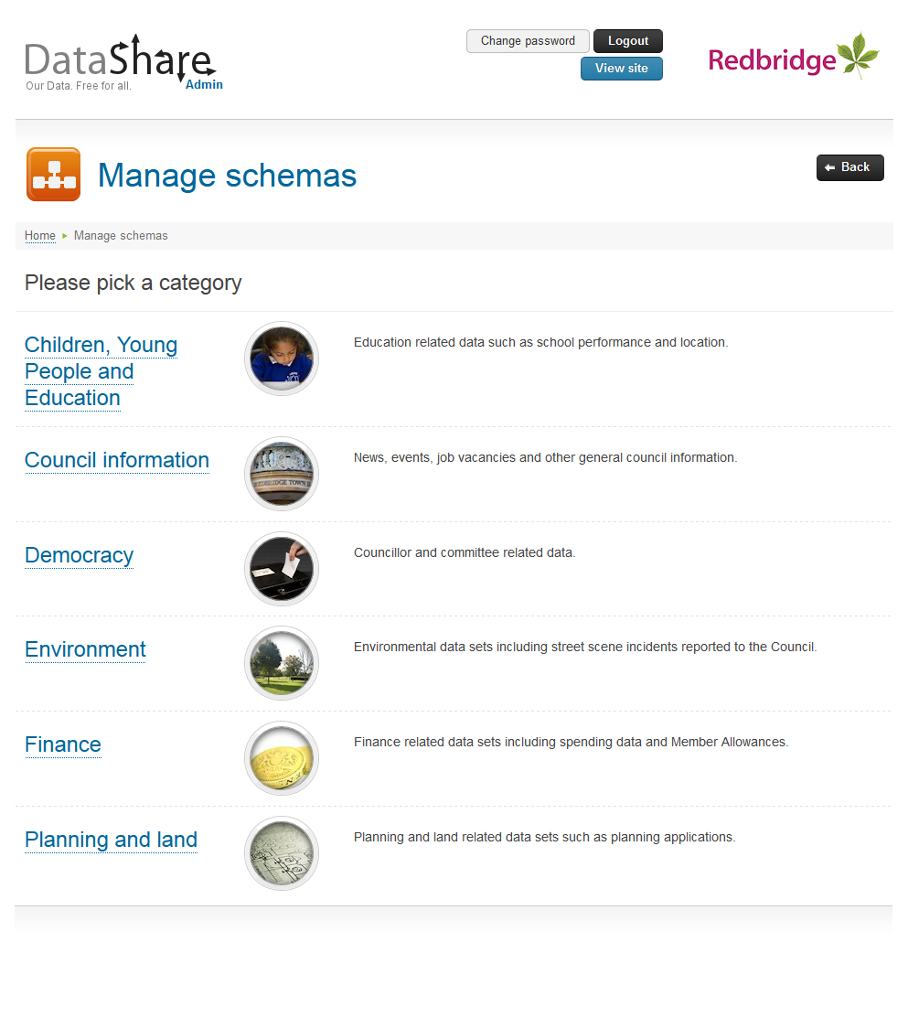
3. Click the required category to manage the schemas within it.
4. The system displays the Manage schemas – Pick a schema page: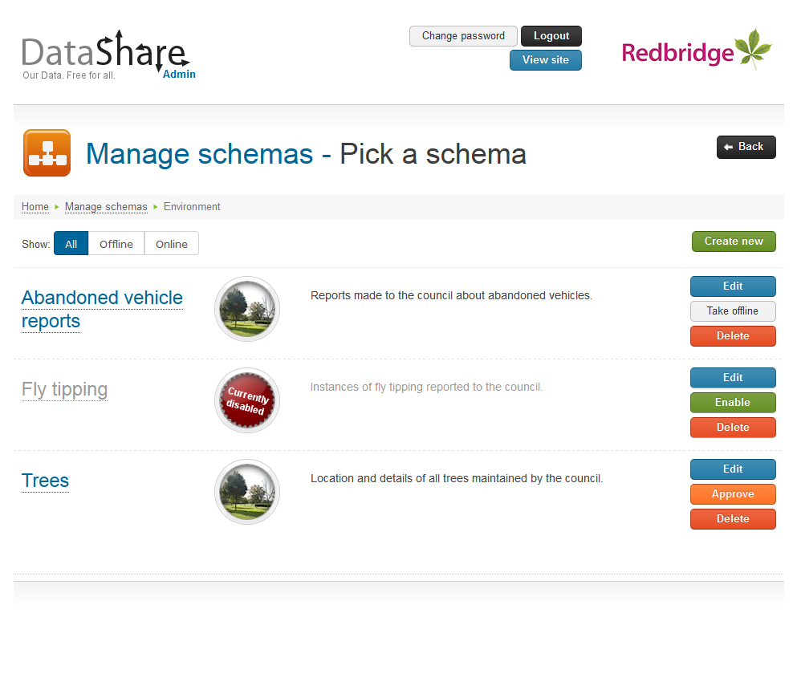

The options on this page allow you to:

|  |  |
| --- | --- |
| ***All*** | View all schemas within the category. |
| ***Offline*** | See only those schemas in the selected category that are currently disabled. |
| ***Online*** | See only those schemas in the selected category that are enabled. |
| ***Create new*** | Create a new schema in the selected category. |
| ***Edit*** | Amend the details and/or structure of the selected schema. |
| ***Approve*** | Allows Super administrators to make the selected, new schema available on the front end site. |
| ***Take Offline*** | Disables the selected schema, temporarily removing it from the front end site. |
| ***Enable*** | Makes a previously disabled schema available once again. |
| ***Delete*** | Removes the selected schema and all associated data. |
| ***Back*** | Returns to the Manage schemas page allowing you to select another category. |

## Creating a schema

Only administrators in the SchemaCreator and SuperAdministrator roles can create a new schema.

To create a new schema:

1. From the Manage schemas page, click the category you wish to create the schema in.
2. Click the ***Create new*** button.
3. 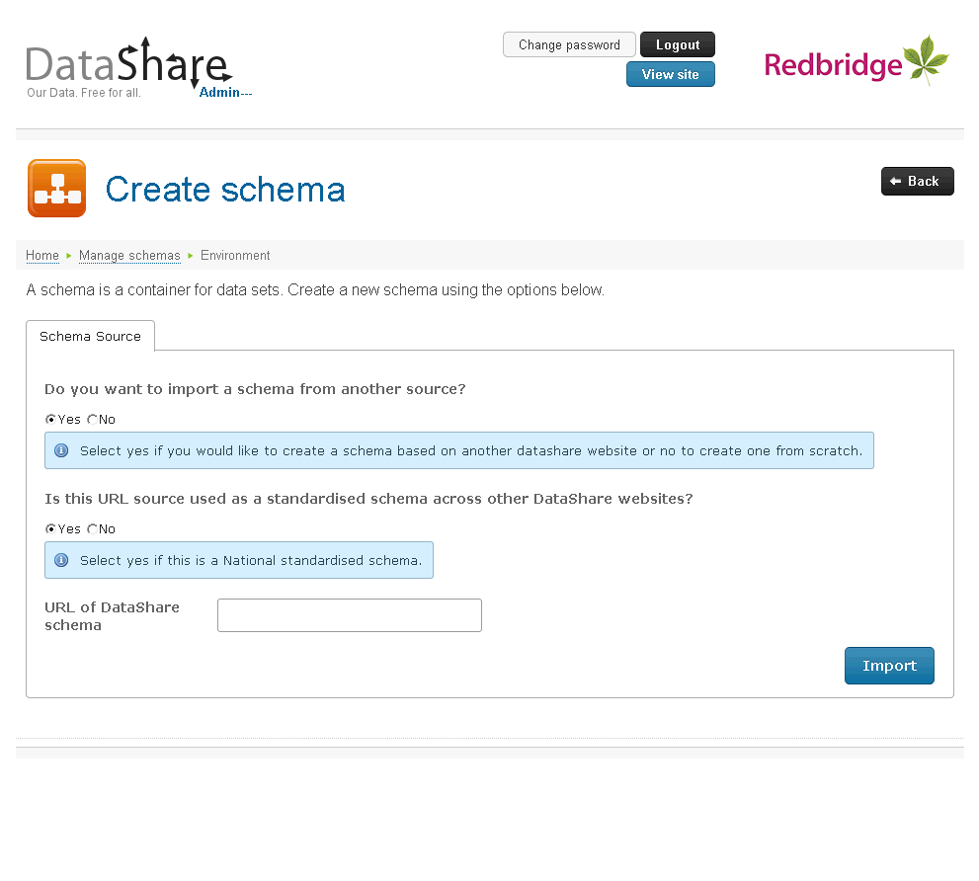The system displays the Create schema page:
4. Answer the first question about the schema source as follows:

|  |  |
| --- | --- |
| Do you want to import a schema from another source? | DataShare allows you to import schema definitions from other DataShare instances. These could be schemas that need to adhere to a national standard or simply a quick way of generating a local schema based on another.  Select Yes to import a schema definition (see Importing a schema on page 16), or No to create one from scratch (see page17). |

### Importing a schema

If you answered Yes to the question “Do you want to import a schema from another source?” then the system will ask you provide details of the schema you wish to import.

1. Complete the Schema source forms as follows:

|  |  |
| --- | --- |
| Is this URL source used as a standardised schema across other DataShare websites? | If the schema you are importing needs to adhere to a national standard then select Yes.  Select No if you are importing a schema a quick method of creating a similar one. |
| URL of DataShare schema | The URL of the DataShare schema definition you wish to import.  Schema definition URLs are in the format:  <datashareurl>/api/category-name/schema-title/definition |

1. Click the ***Import*** button.
2. The system will create the schema definition and create a new a new schema based on that definition and allow you edit limited details.

See page 23 for details of editing a schema.

### Creating a schema from scratch

If you answered No to the question “Do you want to import a schema from another source?” then the system will ask you provide details of the schema you wish to create.

1. On the Schema source page, click the ***Next*** button.
2. The system displays the Create schema, Step 1 – Schema detail page.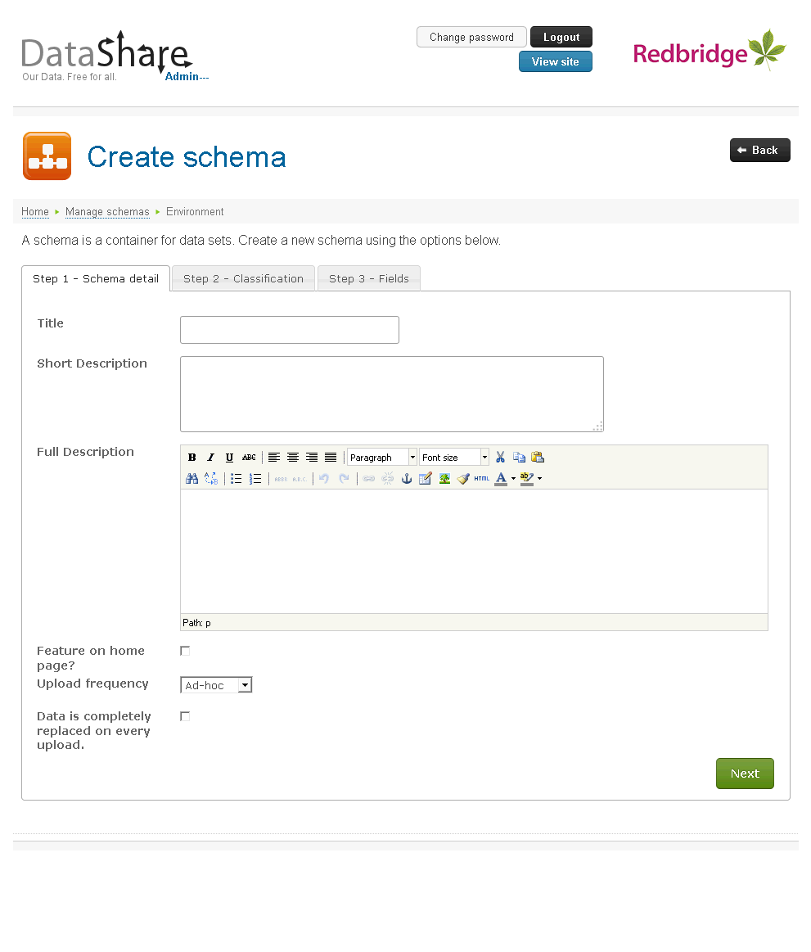
3. Complete Step 1 – Schema detail as follows:

|  |  |
| --- | --- |
| Title | The name of the schema. This should be as concise as possible.  The title (with spaces and punctuation replaced by hyphens) will form part of the URL to view and download the schema’s data. e.g. <datashareurl>/View/category-name/schema-title  The title can be a maximum of 500 characters long. |
| Short Description | A brief description of the schema. This will appear alongside the schema title on both the front end and admin sites.  The short description can be a maximum of 500 characters long. |
| Full Description | A more detailed description of the schema. This will appear in a pop-up when a visitor clicks the  icon alongside the schema title when viewing a schema’s data.  The full description can contain HTML and therefore uses an in-line editor. For help with using the editor please see page 40. |
| Feature on home page? | Select this option to have the schema name and short description featured on the DataShare home page.  Up to three featured schemas will appear on the site’s home page. |
| Upload frequency | The frequency that data should be added to the schema. |
| Data is completely replaced on every upload. | Select this option if uploaded data should replace the existing data rather than be appended. |
| Owner email address | For schemas that should have data regularly uploaded an owner’s email address is required. Reminder emails will be sent to this address. |

1. Click the ***Next*** button.
2. The system will validate the details; any problems will be displayed on the page and must be corrected before you are able to continue.
3. Once valid, the system will save the schema details entered so far and display the Edit schema Step 2 – Classification page.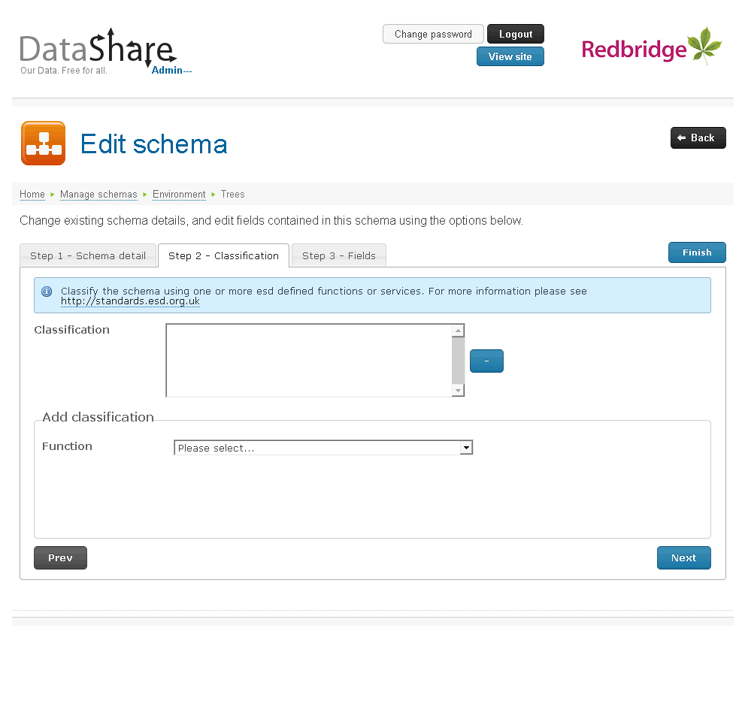
4. Classify your schema using one or more Functions/Services from the ESD Function and Services list. See [http://standards.esd.org.uk](http://standards.esd.org.uk/?) for more details. To add a Function/Service classification:
   1. Select a function from the Function drop down list.
   2. The system displays a ***+*** button alongside the selected function, and displays the Sub-function drop down list.
   3. If required, select a sub-function from the drop down list.
   4. The system displays a ***+*** button alongside the selected sub-function, and displays the Service drop-down list.
   5. If required select a service from the drop-down list.
   6. The system displays a ***+*** button alongside the selected service.
   7. Click the ***+*** button alongside the appropriate level of classification to add the relevant function/service to the Classification list.
   8. You can repeat this to add as many classifications as required.
   9. A classification added in error can be removed by selecting it in the Classification list and clicking the ***-*** button alongside.
5. Click the ***Next*** button to continue.
6. The system displays the Edit schema Step 3 – Fields page: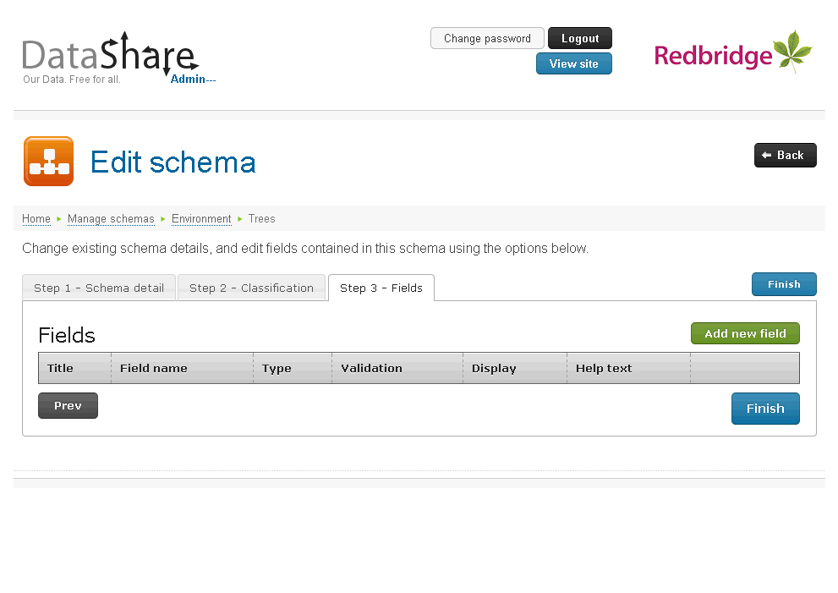
7. Use this page to define the structure of the data you will be uploading. Click the ***Add new field*** button to define the first column in your schema definition.
8. The system displays the Add field to schema page: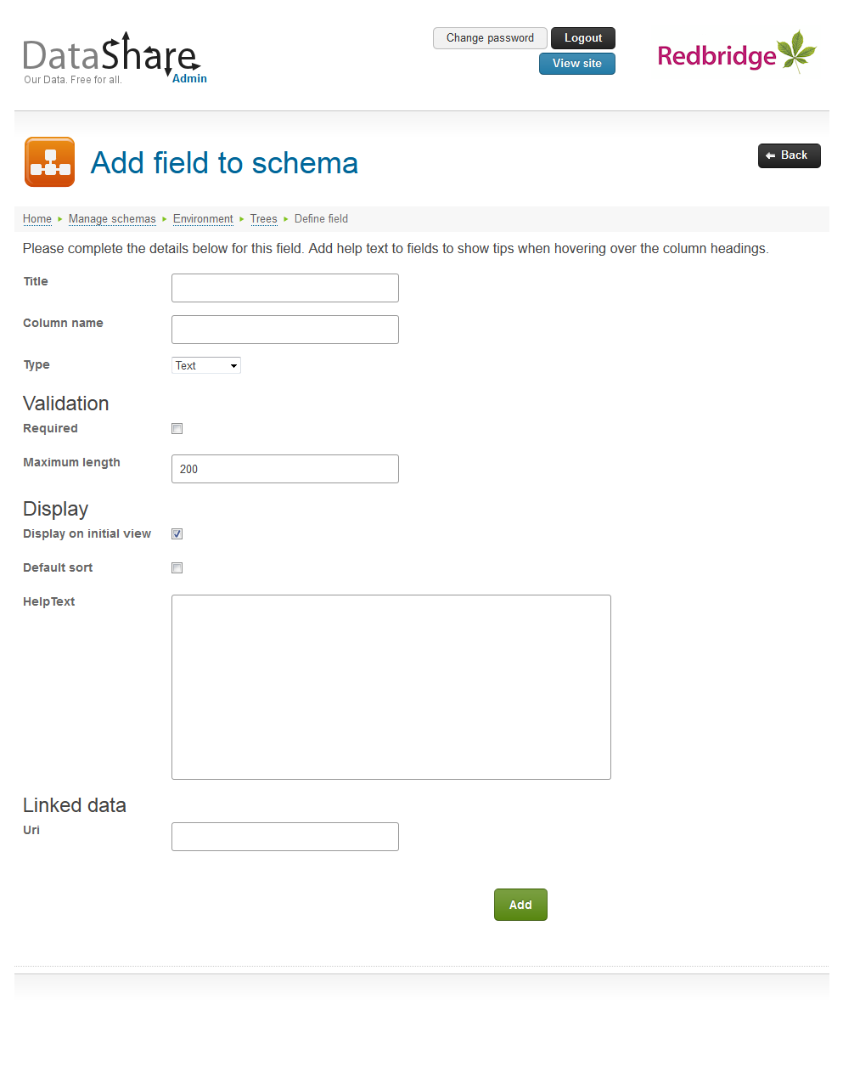
9. Complete the form with the details of the field being added:

|  |  |
| --- | --- |
| Title | A concise title for the field. This will become the column’s heading when viewed on DataShare. |
| Column name | An internal name for the column used to query the data via URL and the DataShare API. It should also be used as a column heading in the CSV file used to upload data.  This will default to the column title with any spaces and punctuation removed.  Once the field has been added you cannot change its column name. |
| Type | The type of data the field will contain. Data uploaded into the schema will be validated according to the data type selected:  Text Textual data such as names, addresses and comments.  Number Numeric data, that calculations may be performed upon, such as quantities.  Currency Numeric data that should be displayed in a financial format such as monetary amounts.  DateTime Dates and times.  URL Web site links. URL fields are displayed on DataShare as a  button that links to the URL specified by the data.  Image Used to store the URL of a web image. Image fields are displayed on DataShare as the image specified by the data itself.  Lat/Lng Geographic data. When adding a Lat/Lng field DataShare will automatically create both Latitude and Longitude fields for you. E.g. adding a Lat/Lng field called ‘Location’ will actually add two fields to the schema definition, one called LocationLatitude and one called LocationLongitude.  Once the field has been added you cannot change its type. |
| **Validation** | These options are used to help validate the data uploaded into the schema. |
| Required | Is this field mandatory for every record uploaded into the schema? |
| Maximum length | Text fields only. The maximum length (in characters) that a text field is permitted to be. |
| Min value | Number, Currency and DateTime fields only. The lowest value or earliest date that this field can contain. Leave this blank to not restrict the data in this way. |
| Max value | Number, Currency and DateTime fields only. The highest value or latest date that this field can contain. Leave this blank to not restrict the data in this way. |
| **Display** | These options affect the default appearance of the data when viewed in DataShare. |
| Display on initial view | Should this column appear by default when a visitor views the data? If this option is not selected the visitor will need to add the column themselves in order to view its data. |
| Default sort | Select this option if the data should be sorted using this field by default. Visitors are able to change the sort order by clicking the column headings when viewing the data.  Only one field in a schema can be selected as the default sort. |
| Sort direction | If the Default sort option is selected you must specify the direction of the sort, Ascending (A to Z, low to high) or Descending (Z to A, high to low). |
| Help text | A description of the data that will be stored in this field. A visitor can display this help text by hovering over the column heading when viewing the data. |
| **Linked data** | DataShare allows for data to be linked across the web e.g. a company number can be linked to data held elsewhere on the web detailing more information about that organisation.  See <http://linkeddata.org/> and <http://en.wikipedia.org/wiki/Linked_data> for more information about linked data. |
| URI | The URI pattern to link the data. Use #Data# to represent where in the URI the field’s data should appear, e.g. http://opencorporates.com/companies/gb/#Data#. |

1. Click the ***Add*** button.
2. The system will validate the details and any problems will be displayed on the page and must be corrected before proceeding.
3. Once all the details are valid the system will save the field definition and return to the Edit schema, Step 3 – Fields page.
4. Continue to add fields to the schema by repeating steps 8 to 13 until all the required fields have been added.
5. Click the ***Finish*** button.
6. The system will return to the Edit schema, Step 1 – Schema detail page.

## Editing a schema

Only administrators in the SchemaEditor, SchemaCreator and SuperAdministrator roles can edit a schema.

You will only be able to amend the display properties of a schema imported as a national standard.

To amend the details of a schema, or change its structure:

1. From the Manage schemas page, click the category of the schema you wish to amend.
2. Click the ***Edit*** button alongside the schema you wish to amend.
3. The system displays the Edit schema, Step 1 – Schema detail page.
4. Change the details as required. See page 17 for details of the fields on this page.

Changing a schema’s title will change the URL used to view, download or access data within that schema.

1. To save any changes and move to Step 2 click the ***Next*** button.
2. The system displays the Edit schema, Step 2 – Classification page.
3. Add or remove function/service classification as required, see on page 24.
4. The system displays the Edit Schema, Step 3 – Fields page.
5. Add, edit or delete fields from the schema structure as required, see on page 25.
6. Click the ***Finish*** button to save all changes.
7. Use the ***Back*** button to return to the Manage schema – Pick a schema page.

## Editing the schema’s classification

The Edit schema, Step 2 – Classification page allows you to classify your schema using one or more Functions/Services from the ESD Function and Services list. See [http://standards.esd.org.uk](http://standards.esd.org.uk/?) for more details of Services and Functions.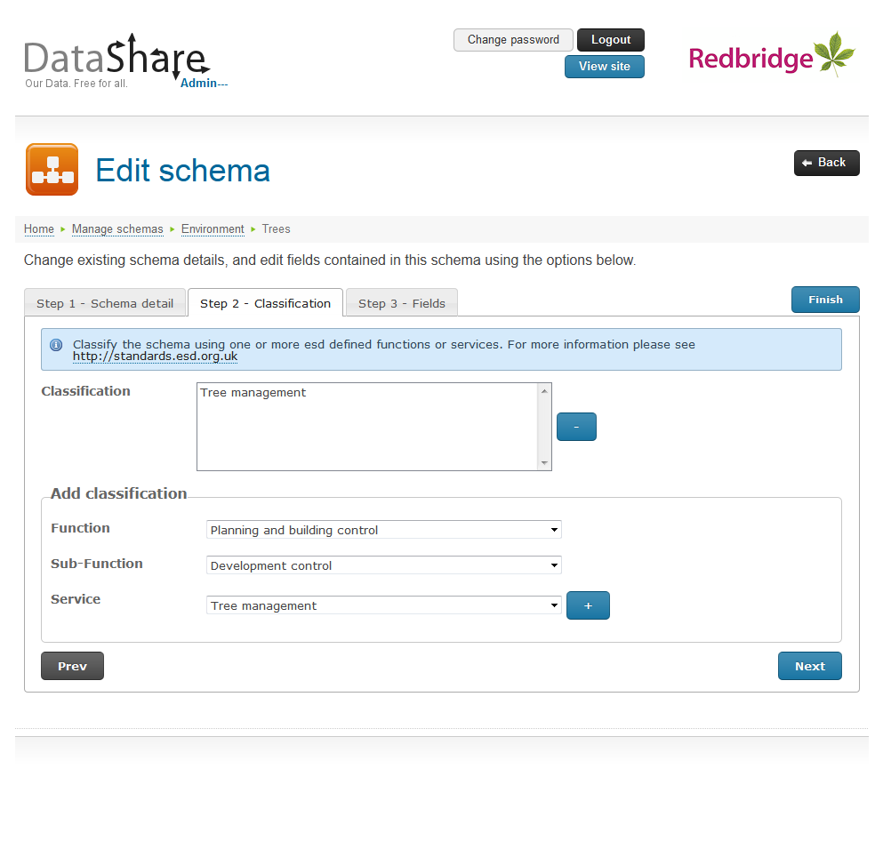

You will not be able to amend the classification of a schema imported as a national standard.

### Adding a Function/Service classification

1. Select a function from the Function drop down list.
2. The system displays a ***+*** button alongside the selected function, and displays the Sub-function drop down list.
3. If required, select a sub-function from the drop down list.
4. The system displays a ***+*** button alongside the selected sub-function, and displays the Service drop-down list.
5. If required select a service from the drop-down list.
6. The system displays a ***+*** button alongside the selected service.
7. Click the ***+*** button alongside the appropriate level of classification to add the relevant function/service to the Classification list.
8. You can repeat this to add as many classifications as required.
9. Click the ***Finish*** button to save your changes or the ***Next*** button if you wish to amend the schema’s fields.

### Removing a Function/Service classification

A classification added in error can be removed.

1. Selecting the relevant classification in the Classification list.
2. Click the ***-*** button alongside.
3. Click the ***Finish*** button to save your changes or the ***Next*** button if you wish to amend the schema’s fields.

## Editing the schema structure

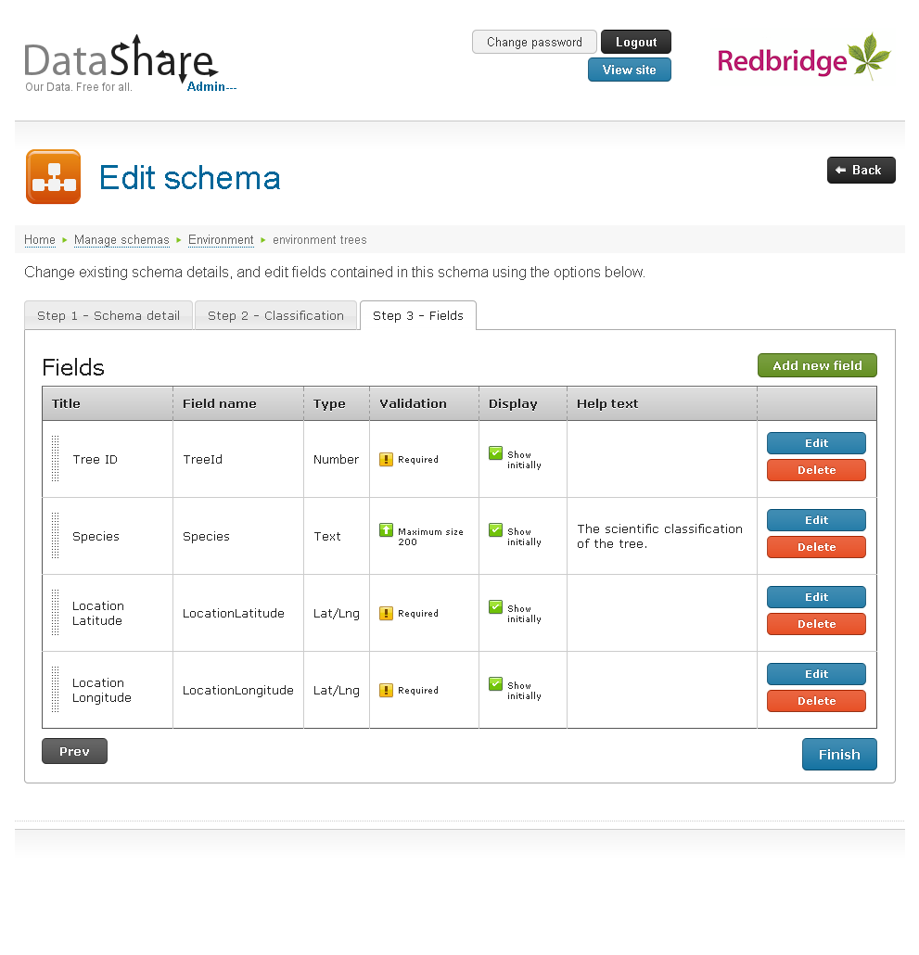The Edit schema, Step 3 – Fields page allows the following actions:

|  |  |
| --- | --- |
| ***Add new field*** | Adds a new field to the schema. Fields are added to the end of the field list. |
| ***Edit*** | Amend the details of the selected field. |
| ***Delete*** | Removes the selected field and all associated data. |
| ***Finish*** | Saves all changes to the schema. |
| ***Prev*** | Displays the Edit schema, Step 2 – Classification page. |
| ***Back*** | Returns to the Manage schemas – Pick a schema page allowing you to select another schema. |

You will not be able to amend the structure of a schema imported as a national standard.

### Adding a field

To add a new field:

1. Click the ***Add new field*** button and follow the instructions for adding a new field that begin on page 20.

### Editing a field

To edit a field’s description:

1. Click the ***Edit*** button alongside the field you wish to amend.
2. The system displays the Update field in schema page: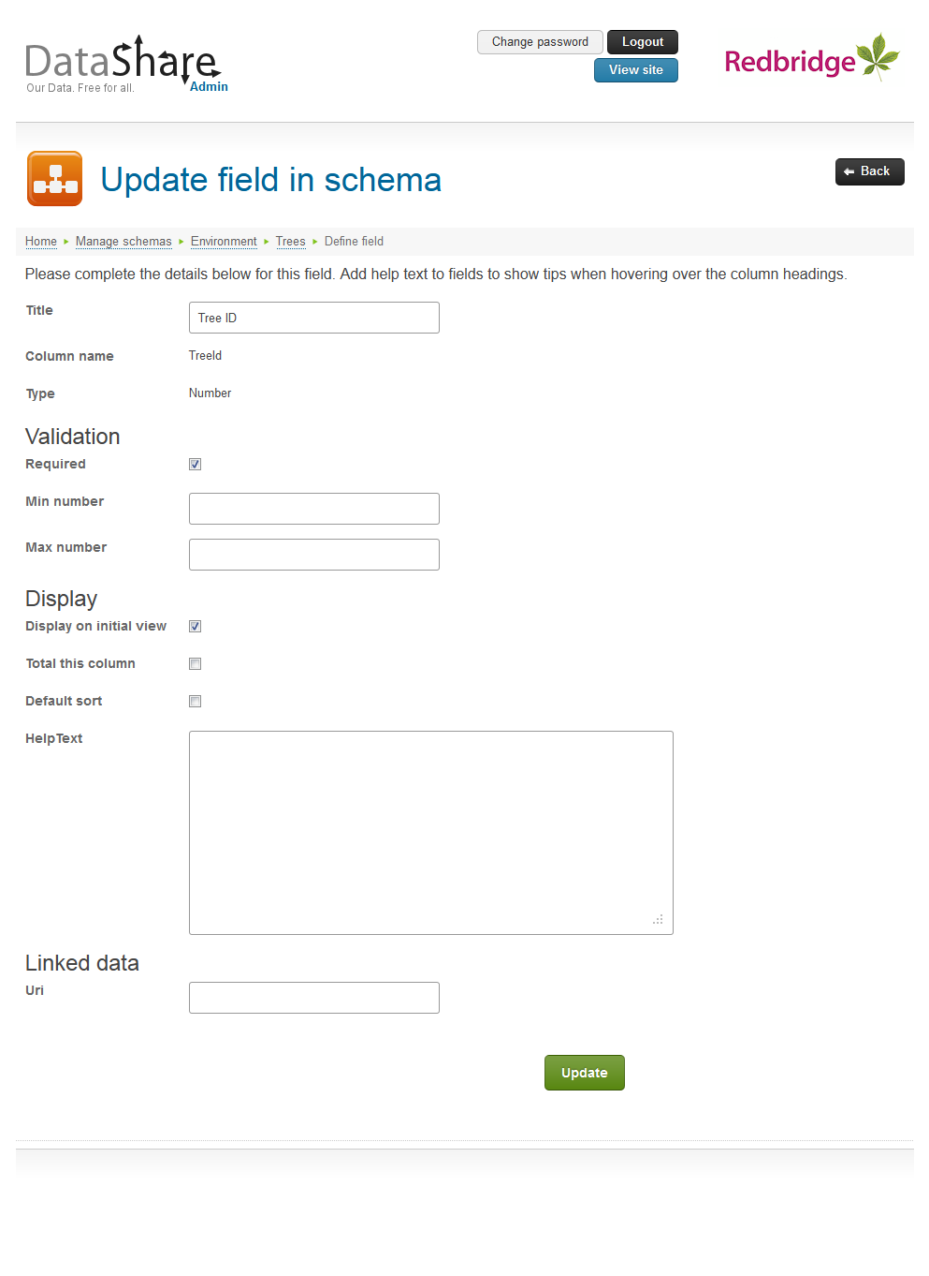
3. Amend the details as required.

The column name and field type are displayed for information only and cannot be amended.

You will only be able to amend the display properties of a schema imported as a national standard.

1. Click the Update button.
2. The system will validate your changes. Any errors will be displayed on the page and must be corrected before continuing.
3. If no problems are found the changes are saved and the system displays the Edit schema, Step 3 – Fields page.

### Deleting a field

To remove a field from the schema’s structure:

1. Click the ***Delete*** button alongside the field you wish to remove.
2. The system will ask you to confirm that you wish to delete the field.
3. Click ***Yes*** to delete the field and **all associated data**, or ***No*** to cancel the operation.

Once a field has been deleted it cannot be retrieved.

### Changing the order of fields

To change the order of fields in the schema’s structure:

1. Point to the drag handle of the field you wish to move.
2. Drag the field, a copy of the field row follows your mouse pointer.
3. Drop the field in its new position.

This will also affect the display order of the columns when a visitor views the data.

## Changing a schema’s online status

Only approved, enabled schemas with data uploaded can be seen on the public DataShare site.

### Approving a schema

Before a schema is available for visitors to see on the public DataShare site it must be approved by a super administrator. To approve a schema:

1. From the Manage schemas page, click the category of the schema you wish to approve.
2. Click the ***Approve*** button alongside the required schema.
3. The system will immediately make the schema available on the public DataShare site. The ***Approve*** button will be replaced by a ***Take offline*** button.

Only users in the SuperAdministrator role can approve schemas.

### Taking a schema offline

Approved schemas can be temporarily removed from the public DataShare site by taking them offline. All of the schema’s details and data are retained by the system, it’s just not available to view or download via the public site, or access via the API. To take a schema offline:

1. From the Manage schemas page, click the category of the schema you wish to take offline.
2. Click the ***Take offline*** button alongside the required schema.
3. The system will prompt you to confirm that you wish to disable the schema and its data.
4. Click ***Yes*** to take the schema and its data offline, or ***No*** to cancel the operation.

### Putting a disabled schema back online

A schema that has been taken offline can be brought back online so that it can be accessed via the front end site and API again. To bring an offline schema back online:

1. From the Manage schemas page, click the category of the schema you wish to bring online.
2. On the Manage schemas – pick a schema page, click the ***Offline*** button to view disabled schemas.
3. Click the ***Enable*** button alongside the schema you wish to bring back online.
4. The system will immediately bring the schema back online and switch the view to display online schemas.

## Deleting a schema

Only administrators in the SchemaCreator or SuperAdministrator roles are able to delete a schema.

To delete a schema:

1. From the Manage schemas page, click the category of the schema you wish to remove.
2. Click the ***Delete*** button alongside the schema you wish to delete.
3. The system will ask you to confirm the deletion of the schema and all associated data.
4. Click ***Yes*** to delete the schema and **all data uploaded into it**, or ***No*** to cancel the operation.

Once a schema has been deleted neither it, nor its data, can be retrieved.

# Managing data

Any DataShare administrator can manage a defined schema’s data, even if the schema has not yet been approved. To manage data:

1. From the DataShare menu select the ***Upload and edit data*** option.
2. The system displays the Upload data – pick a category page, listing all available categories: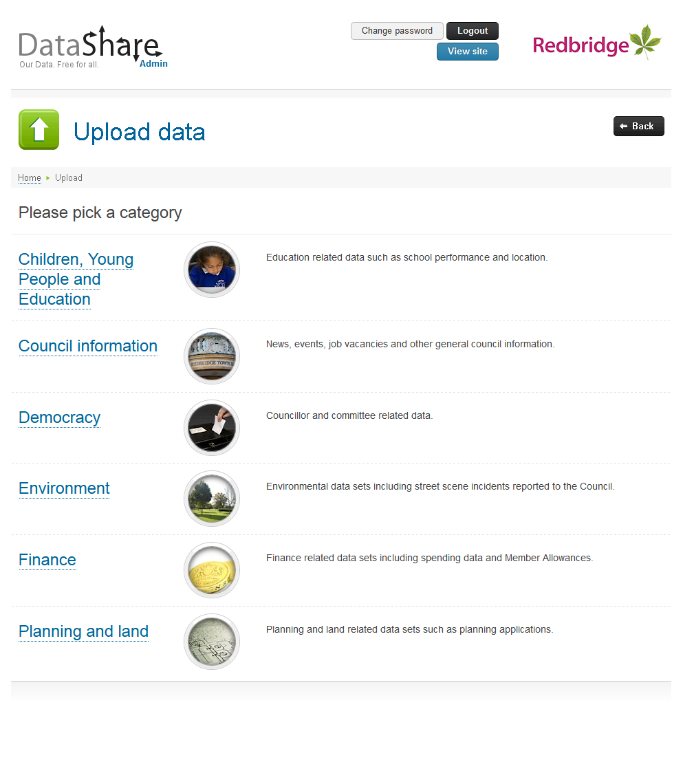
3. Click the category that contains the schema whose data you wish to manage.
4. The system displays the Upload data – pick a schema page: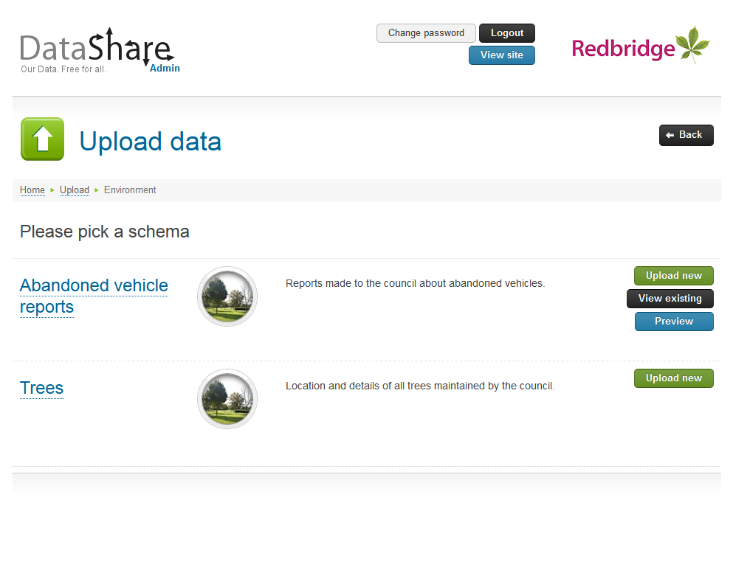

The options on this page allow you to:

|  |  |
| --- | --- |
| ***Upload new*** | Add new data to the selected schema. |
| ***View existing*** | See existing data sets that have been added to the selected schema. |
| ***Preview*** | View the selected schema’s data via the front end DataShare site. This is available even if the schema has not yet been approved. |
| ***Back*** | Return to the Upload data – pick a category page. |

## Uploading data

To upload new data to a schema:

1. From the Upload data – pick a schema page, click ***Upload new*** alongside the required schema.
2. The system displays the Upload a new data set page: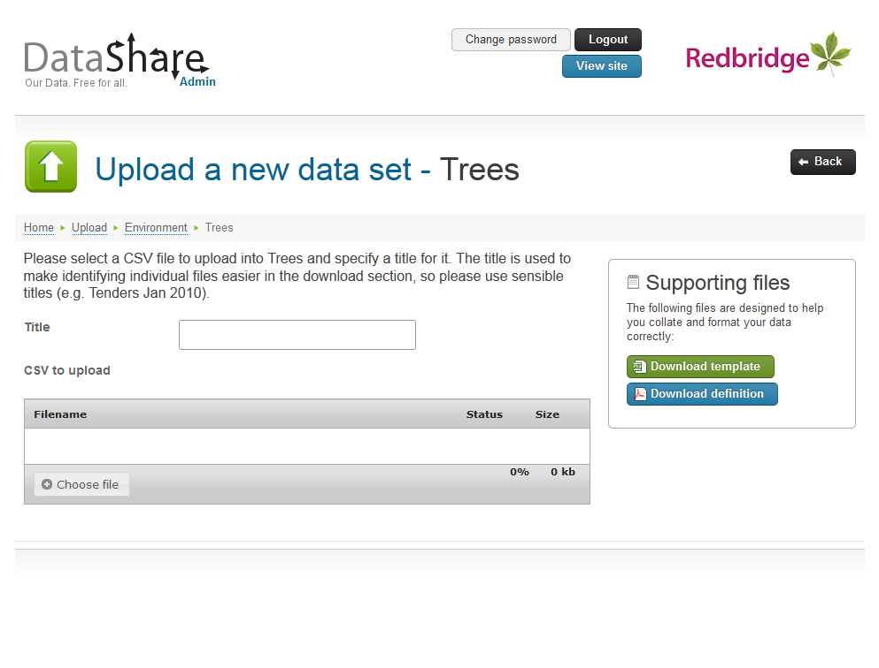
3. Enter a title for this data set. The title is used to make identifying individual files easier in the download area of DataShare and should therefore distinguish this set of data from others that may have been uploaded to this schema previously.
4. Click the ***Choose file*** button to browse your computer’s file system for the CSV file you wish to upload.
5. Upon selecting the file the system will attempt to upload the data into the schema, using the schema’s definition to validate the data within the CSV file. Any errors will be displayed on the page and must be corrected within the file before attempting to upload again.
6. If no problems are encountered the system will upload the data. If the schema definition has the “Data is completely replaced on every upload” option selected all existing data will be deleted and replaced by the data being uploaded, otherwise the uploaded data set is appended to the existing data sets.
7. The system displays the data successfully uploaded page: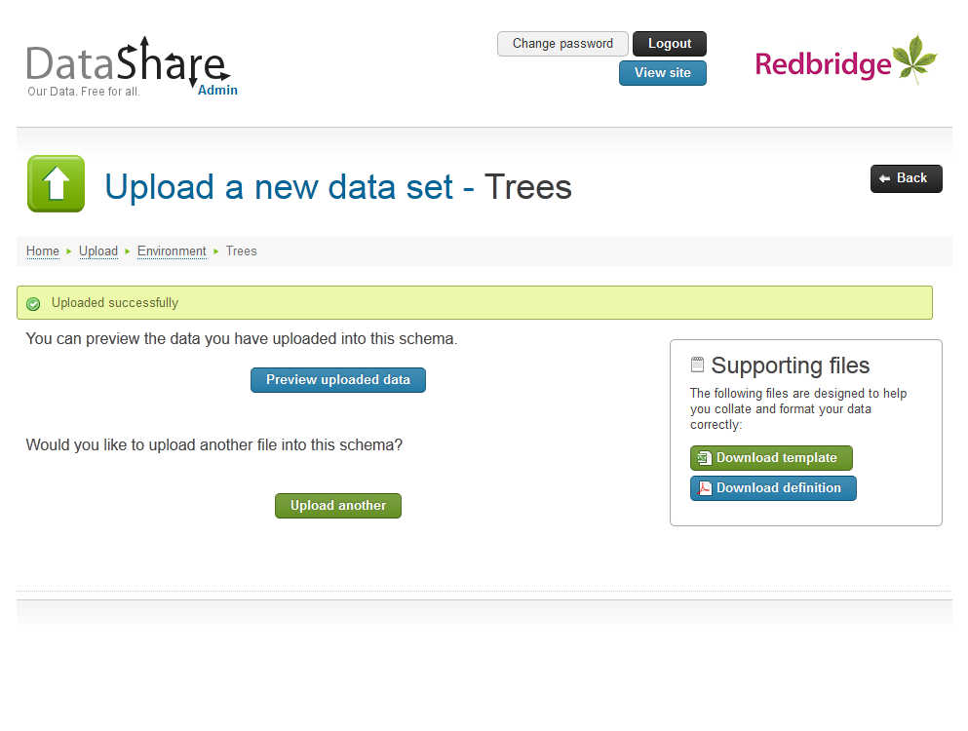
8. You may use one of the following options:

|  |  |
| --- | --- |
| ***Preview uploaded data*** | If the schema has not yet been approved this button gives you to opportunity to view the data via the DataShare front end site. Schemas that are not approved are not available on the front end site and can only been viewed via the ***Preview*** button.  If the schema has been approved this option will not be displayed. |
| ***Upload another*** | Returns you to the Upload a new dataset page so that an additional file can be uploaded to the schema. |
| ***Back*** | Return to the Upload data – pick a schema page. |

### Supporting files

To help create a correctly formatted CSV file the Upload a new data set page contains supporting files to download via the following buttons:

|  |  |
| --- | --- |
| ***Download template*** | Download a template for the CSV file needed for this schema. The template will contain the column headings specified in the schema definition but no data. |
| ***Download definition*** | Download a PDF document containing the full definition of the schema including all validation conditions.  PDF (Portable Document Format) files can be viewed using the free [Adobe Acrobat Reader](http://get.adobe.com/uk/reader/). |

### Auto-upload

The DataShare Service allows for CSV files added to a watched folder to be automatically uploaded. The location of this folder is set during the installation of the service to:

<Service Installation Folder>\FolderWatch

The service automatically creates a sub-folder for each schema added to DataShare, using the schema’s ID number as the folder name. This ID number can be seen on the schema’s Edit Schema page.

Once a day the DataShare Service will attempt to upload any CSV files placed in these sub-folders to the relevant schema. It will log the action taken or any errors encountered (see Service history and errors on page 37). If an email address is provided for the schema, it will also email the schema owner to notify them of the upload. The service will delete any files from the watched folder that are successfully uploaded.

## Deleting data

Existing data sets can be removed from the system if required.

To delete a data set from a schema:

1. From the Upload data – pick a schema page, click ***View existing*** alongside the required schema.
2. The system displays the Update data sets page: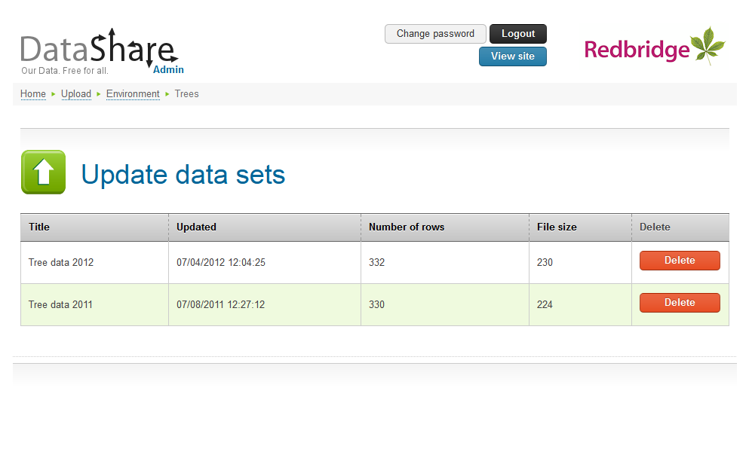
3. Click the ***Delete*** button alongside the data set you wish to remove.
4. The system will prompt you to confirm that you wish to delete the data set.
5. Click ***Yes*** to delete the data from the system, or ***No*** to cancel the operation.

Once the data set has been deleted it cannot be retrieved.

# Managing categories

Only administrators in the SuperAdministrator role can manage categories.

DataShare groups related schemas into categories. Super administrators can add new categories, amend existing ones or take a whole category of schemas offline.

To manage categories:

1. From the DataShare menu select the ***Add and edit categories*** option.
2. The system displays the Manage categories page: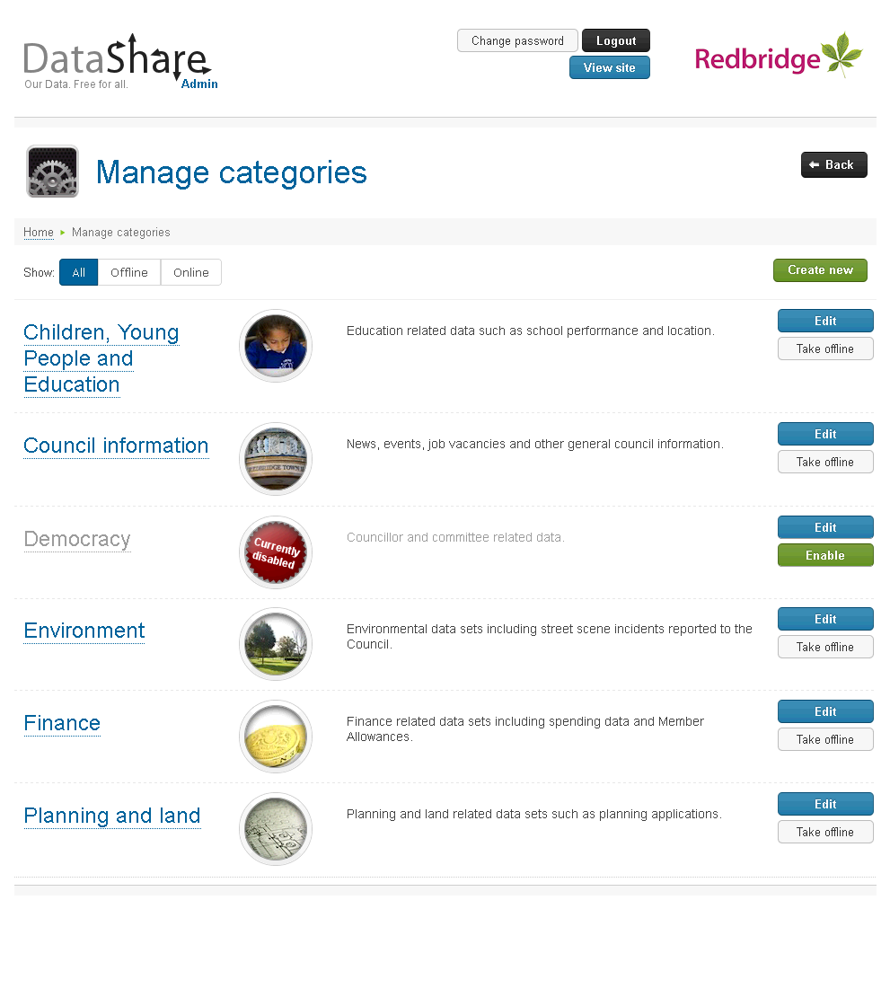

Options on this page allow you to:

|  |  |
| --- | --- |
| ***All*** | View all categories regardless of online status. |
| ***Offline*** | View only those categories that have been taken offline. |
| ***Online*** | View only those categories that are currently enabled. |
| ***Create new*** | Create a new category. |
| ***Edit*** | Amend the name and description of a category. |
| ***Take offline*** | Disable the category and all schemas within it. |
| ***Enable*** | Makes a previously disabled category available once more. |

## Create a category

If required, additional categories can be created. To create a new category:

1. From the Manage categories page, click the ***Create new*** button.
2. The system displays the Create category page: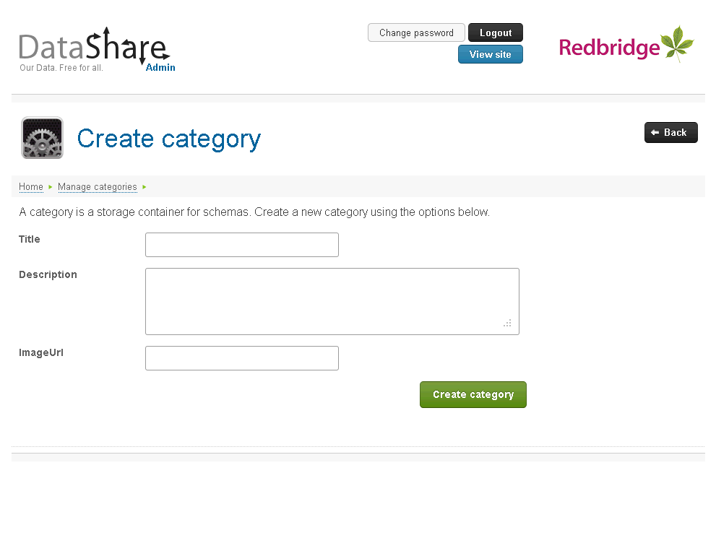
3. Complete the form as follows:

|  |  |
| --- | --- |
| Title | The name of the category. This should be as concise as possible.  The title (with spaces and punctuation replaced by hyphens) will form part of the URL to view and download data from the schemas within the category. e.g. <datashareurl>/View/category-name/schema-title  The title can be a maximum of 75 characters long. |
| Description | A short description of the type data to found within the category. This appears alongside the category and can be used to help visitors find the data they are looking for.  The description can be a maximum of 500 characters long. |
| ImageURL | The URL of an image to represent this category. Images should be 80 pixels square. If no URL is specified a generic image will be used. |

1. Click the ***Create category*** button.
2. The system will validate the details entered and any errors will be displayed on the page.
3. Once the data entered validates the system will create the category and return to the Manage categories page.

## Editing a category

The title, description and image used for a category can be changed at any time. To amend the details of a category:

1. From the Manage categories page, click the ***Edit*** button alongside the required category.
2. The system displays the Edit category page.
3. Amend the details as required.

Changing the category’s title will change the URL used to view, download or access data within that category.

1. Click the ***Save category*** button.
2. The system will validate the details, any errors will be displayed on the page and must be corrected.
3. Once valid, the system will save the changes.
4. Click the ***Back*** button to return to the Manage categories page.

## Changing a category’s online status

### Taking a category offline

Whole categories of schemas can be temporarily removed from the public DataShare site by taking them offline. All of the category’s schemas and data are retained by the system, they just not available to view or download via the public site, or access via the API.

To take a category offline:

1. From the Manage categories page, click ***Take offline*** alongside the required category.
2. The system will prompt you to confirm that wish to disable all schemas and data within the category.
3. Click ***Yes*** to confirm you wish to take the category offline, or ***No*** to cancel the operation.

### Putting a disabled category back online

A category that has been taken offline can be brought back online so that it can be accessed on the front end DataShare site and via the API again.

To bring an offline category back online:

1. From the Manage categories page, click the ***Offline*** button to view disabled categories.
2. Click the ***Enable*** button alongside the category you wish to bring online.
3. The system will immediately bring the category back online and switch the view to display online categories.

# Feedback

Only administrators in the SuperAdministrator role can view feedback.

The public DataShare site allows visitors to submit their feedback, enquiries and suggestions for data sets.

To view these comments:

1. From the DataShare menu select the ***View feedback*** option.
2. The system displays the View feedback page: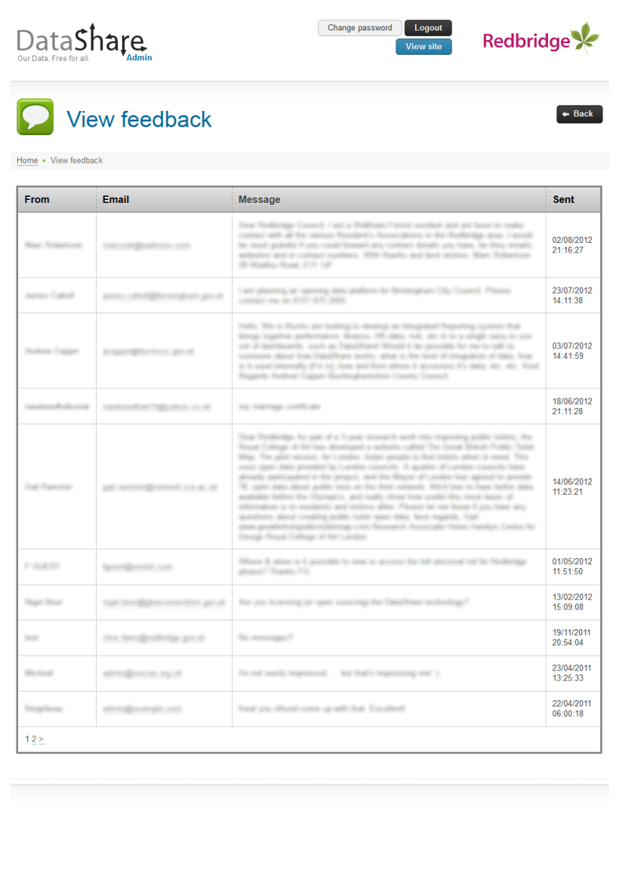
3. To respond to a comment or request click the email address of the sender.

# Service history and errors

Super administrators have the ability to inspect details of events raised by the automated service such as files auto-uploaded and reminder emails sent. They can also view errors logged by the system.

During normal day to day running there should be no need to access these options, however they can help to diagnose issues if errors or problems occur.

## Service history

To view service history:

1. From the main menu select the ***View service history*** option.
2. The system displays the Service history page: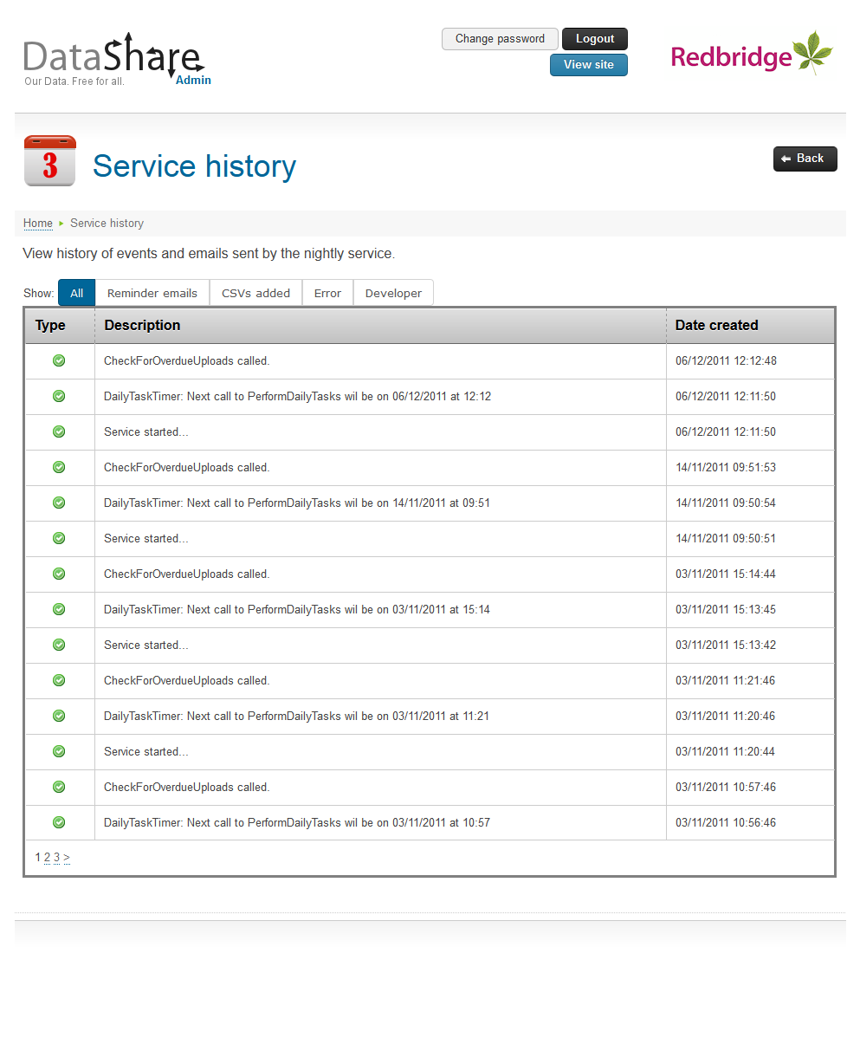
3. Use the options at the top of the table to filter the events table by ***Reminder emails***, ***CSVs added***, ***Error*** or ***Developer*** related messages.

## Errors

To view errors raised by the web site:

1. From the main menu select the ***View errors*** option.
2. The system displays the Error log page: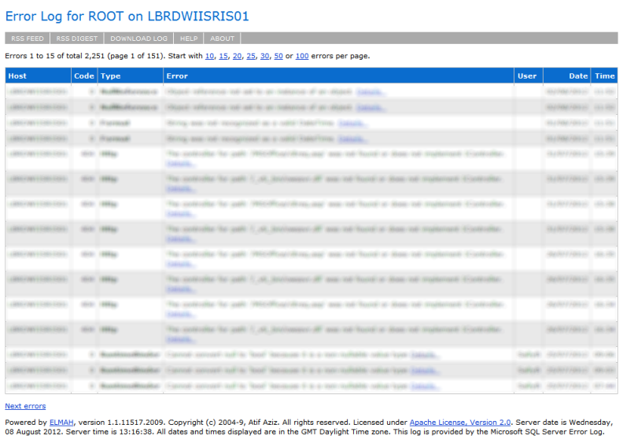

# Appendices

## Planning a schema

Before using the system to create a new schema and upload data it pays to plan in advance. Here are a few tips, dos, don’ts and other points to bear in mind:

* Don’t be prescriptive about the value of the data.
* Publish as much data as possible. There must be a compelling personal or legal reason for keeping data confidential.
* Start with data which can be easily exported or extracted from the systems you use.
* Uploaded files must be in CSV format and contain the raw data only; do not include aggregated data such as totals in the data or corresponding schema.
* The CSV file should not contain any empty rows and its data should not be formatted, e.g. £1,234.56 should appear as 1234.56 in the CSV file.
* Don’t filter data into separate schemas. Keep the data as raw as possible and allow visitors to decide how the data should be filtered.
* Additional data sets can be added to a single schema on a regular basis, so rather than define a separate schema for each year or month, include the period as a field within the schema definition. This will allow visitors to filter by the period of interest.
* Ensure that each column defined in a schema contains a single fact. This makes filtering the data easier for visitors.
* Select the most appropriate data type when defining fields in a schema, e.g.
* Reference numbers are often not actually Numbers; as they often contain alphabetic characters, hyphens, slashes, spaces and other characters they should use the Text type.
* Need a “Year” field? What does the data look like? If the column contains values such as “2011” and “2012” then you could define the field using the Number type, however as no calculations will need to be performed on the data, a Text field would suffice. If the data contains values such as “2011/12” then you must use Text as the type.
* Ensure that date data is formatted correctly (dd/mm/yyyy) and use the DateTime type. Do not format the date as a text string such as “2nd September 2011” and use the Text data type as this makes it difficult for visitors to filter by time periods.
* Add descriptions and help text wherever possible. This will add context to the data and help visitors to make sense of the information.
* If individual records in the dataset require a comment, then add a Comment column to the schema.

## DataShare API

DataShare includes an Applications Programming Interface (API) which provides programmatic access to all datasets and associated meta data. The API implements RESTful interfaces which allow developers to perform simple queries on the available data. XML and JSON representations of the data are available.

Details of the API calls available and examples of their use can be found on the Developers page of any DataShare web site; <datashareurl>/developer, e.g. http://data.mycouncil.gov.uk/developer.

Please note that the <datashareurl>/api/esdInventory API call can be used by agencies such as data.gov.uk to harvest datasets from your DataShare site.

## HTML editor

Schema full descriptions are able to hold HTML, allowing the pop up that appears when a visitor clicks the relevant icon to contain formatted text, hyperlinks, images, lists, etc. To this end, the DataShare admin system provides a WYSIWYG HTML editor offering a familiar word-processing interface to use when editing these descriptions.

The toolbar provides many standard editing commands: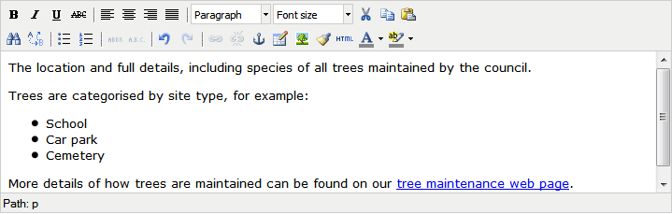

Hovering over any of the buttons will display a tool-tip informing you of what that button does.

Most facilities will be familiar to web page editors and word processing users; however the following may be of interest.

The paste operation is not available if you are using the Firefox browser.

### Inserting an image

To insert an image:

1. Upload an image (probably via your Content Management System) to a web server.
2. Click the ***Insert/edit*** image button.
3. 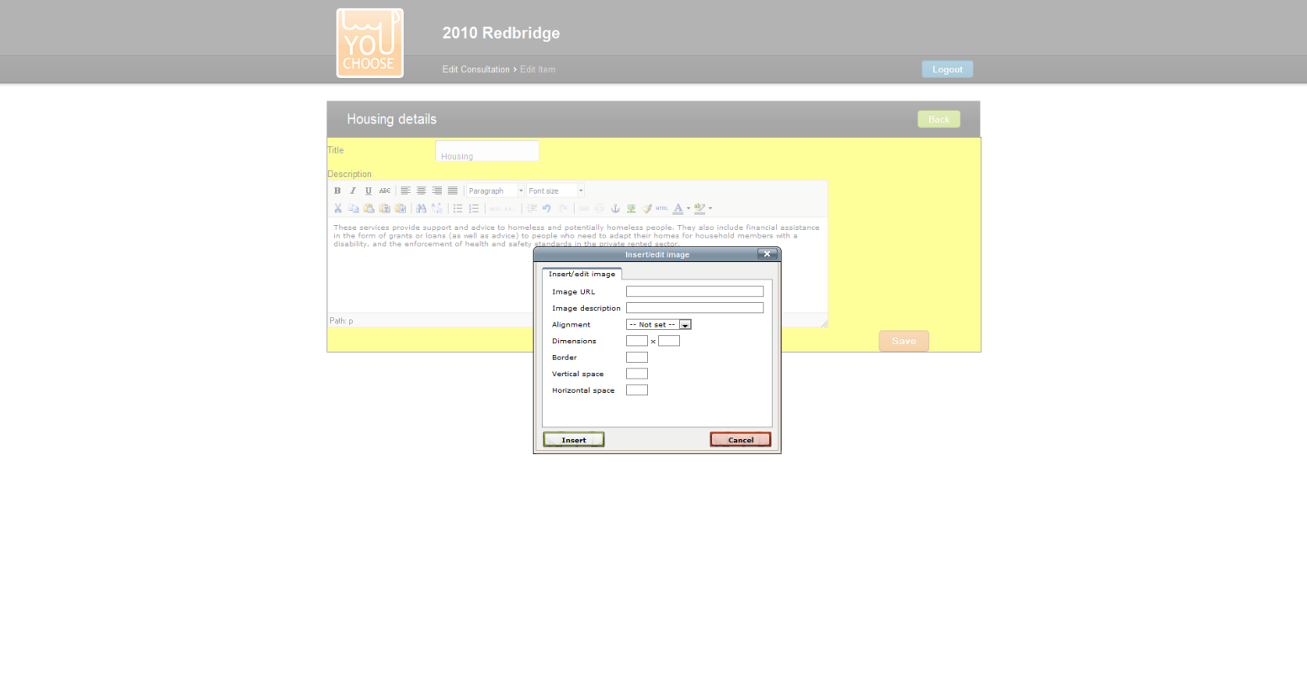The system displays the Insert/edit image dialog box:
4. Complete the image properties as follows:

|  |  |
| --- | --- |
| Image URL | The web address of the image uploaded earlier. |
| Image description | A short description of the picture to use for the ALT attribute. This will be seen before the picture loads (or if it fails to load) and is used by visually impaired users. |
| Alignment | How the image should align with surrounding text. |
| Dimensions | The size of the image in pixels. This will be automatically completed once the image URL is entered. |
| Border | The width in pixels of any border to display around the image. |
| Vertical space | Any spacing (in pixels) above and below the image. |
| Horizontal space | Any spacing (in pixels) to the left and right of the image. |

1. Click the ***Insert*** button to add the image, or ***Cancel*** to abandon the operation.

### Creating a hyperlink

To create a link to a web page:

1. Select the word or phrase to use as the hyper text.
2. Click the ***Insert/Edit link*** button.
3. The system displays the Insert/Edit link dialog box: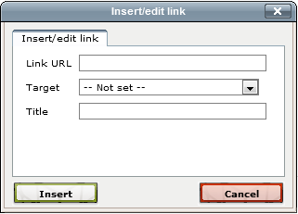
4. Complete the link properties as follows:

|  |  |
| --- | --- |
| Link URL | The web address of the page you are linking to. |
| Target | Select whether the link should open in the same or a new browser window/tab. |
| Title | A title for the link. |

1. Click the ***Insert*** button to create the link, or ***Cancel*** to abandon the operation.